2015 Updating and Screening Assessment for
East Renfrewshire Council

In fulfillment of Part IV of the
Environment Act 1995
Local Air Quality Management

April 2015

Local Authority Officer | East Renfrewshire Council
Department | Environmental Health
Address | Thornliebank Depot, Carnwadric Road, Thornliebank, G46 8HR
Telephone | 0141 577 3782
e-mail | claire.reid@eastrenfrewshire.gov.uk
Report Reference number | EH0415
Date | 30 April 2015

Executive Summary

East Renfrewshire Council has been monitoring air quality across the district since 1996. Air quality within East Renfrewshire has generally complied with air quality objectives and there has therefore been no need to declare any Air Quality Management Areas to date.

The results of East Renfrewshire Council’s air quality monitoring are reviewed and published annually; this report covers the calendar year 2014. The data from 2014 demonstrates that national air quality objectives were again met at all monitoring sites. There is therefore no requirement to proceed to a detailed assessment at this time.

East Renfrewshire Council will continue to monitor air quality throughout 2015 and will publish the results of this monitoring in April 2016.

Table of contents
1 Introduction 6
1.1 Description of Local Authority Area 6
1.2 Purpose of Report 6
1.3 Air Quality Objectives 7
1.4 Summary of Previous Review and Assessments 8
2 New Monitoring Data 10
2.1 Summary of Monitoring Undertaken 10
2.1.1 Automatic Monitoring Sites 10
2.1.2 Non-Automatic Monitoring Sites 10
2.2 Comparison of Monitoring Results with Air Quality Objectives 12
2.2.1 Nitrogen Dioxide 12
3 Road Traffic Sources 17
3.1 Narrow Congested Streets with Residential Properties Close to the Kerb 17
3.2 Busy Streets Where People May Spend 1-hour or More Close to Traffic 17
3.3 Roads with a High Flow of Buses and/or HGVs. 17
3.4 Junctions 18
3.5 New Roads Constructed or Proposed Since the Last Round of Review and Assessment 18
3.6 Roads with Significantly Changed Traffic Flows 18
3.7 Bus and Coach Stations 18
4 Other Transport Sources 19
4.1 Airports 19
4.2 Railways (Diesel and Steam Trains) 19
4.2.1 Stationary Trains 19
4.2.2 Moving Trains 19
4.3 Ports (Shipping) 19
5 Industrial Sources 20
5.1 Industrial Installations 20
5.1.1 New or Proposed Installations for which an Air Quality Assessment has been Carried Out 20
5.1.2 Existing Installations where Emissions have Increased Substantially or New Relevant Exposure has been Introduced 20
5.1.3 New or Significantly Changed Installations with No Previous Air Quality Assessment 20
5.2 Major Fuel (Petrol) Storage Depots 20
5.3 Petrol Stations 21
5.4 Poultry Farms 21
6 Commercial and Domestic Sources 22
6.1 Biomass Combustion – Individual Installations 22
6.2 Domestic Solid-Fuel Burning 22
7 Fugitive or Uncontrolled Sources 23
8 Conclusions and Proposed Actions 24
8.1 Conclusions from New Monitoring Data 24
8.2 Conclusions from Assessment of Sources 24
8.3 Proposed Actions 24

List of Tables
Table 1.1 Air Quality Objectives included in Regulations for the purpose of LAQM
Table 2.1 Details of Non-Automatic Monitoring Sites
Table 2.2 Results of Nitrogen Dioxide Diffusion Tubes in 2014
Table 2.3 Results of Nitrogen Dioxide Diffusion Tubes (2010 to 2014)

List of Figures

Figure 2.1 Trends in Annual Mean Nitrogen Dioxide Concentrations measured at Diffusion Tube Monitoring Sites

Appendices
Appendix A Maps of Diffusion Tube Locations
Appendix B Full Diffusion Tube Results 2014

Introduction

Description of Local Authority Area

East Renfrewshire covers an area of approximately 18,000 hectares to the south and west of Glasgow. The north of the area comprises the suburban residential areas of Giffnock, Newton Mearns, Clarkston and Thornliebank and the town of Barrhead. There is also an extensive rural area within which the villages of Uplawmoor, Neilston, Waterfoot and Eaglesham are located. Approximately 75% of the district is agricultural land. There are no major industrial or commercial sources of air pollutants within East Renfrewshire.

East Renfrewshire has a population of 89,950 (National Records of Scotland 2011). 60% of residents are of working age, with 70% of the working population travelling outside the authority to work. Currently 16% of employees travel to work by bus or rail. The level of car ownership is amongst the highest in Scotland, with 82% of households owning a car.

Purpose of Report
This report fulfils the requirements of the Local Air Quality Management process as set out in Part IV of the Environment Act (1995), the Air Quality Strategy for England, Scotland, Wales and Northern Ireland 2007 and the relevant Policy and Technical Guidance documents. The LAQM process places an obligation on all local authorities to regularly review and assess air quality in their areas, and to determine whether or not the air quality objectives are likely to be achieved. Where exceedences are considered likely, the local authority must then declare an Air Quality Management Area (AQMA) and prepare an Air Quality Action Plan (AQAP) setting out the measures it intends to put in place in pursuit of the objectives.

The objective of this Updating and Screening Assessment is to identify any matters that have changed which may lead to risk of an air quality objective being exceeded. A checklist approach and screening tools are used to identify significant new sources or changes and whether there is a need for a Detailed Assessment. The USA report should provide an update of any outstanding information requested previously in Review and Assessment reports.

Air Quality Objectives
The air quality objectives applicable to LAQM in Scotland are set out in the Air Quality (Scotland) Regulations 2000 (Scottish SI 2000 No 97), the Air Quality (Scotland) Amendment Regulations 2002 (Scottish SI 2002 No 297), and are shown in Table 1.1. This table shows the objectives in units of microgrammes per cubic metre μg/m³ (milligrammes per cubic metre, mg/m³ for carbon monoxide) with the number of exceedences in each year that are permitted (where applicable).

Table 1.1 Air Quality Objectives included in Regulations for the purpose of LAQM in Scotland
Pollutant | Air Quality Objective |  | Date to be achieved by
Pollutant | Concentration | Measured as | Date to be achieved by
Benzene | 16.25 µg/m³ | Running annual mean | 31.12.2003
Benzene | 3.25 µg/m³ | Running annual mean | 31.12.2010
1,3-Butadiene | 2.25 µg/m³ | Running annual mean | 31.12.2003
Carbon monoxide | 10.0 mg/m³ | Running 8-hour mean | 31.12.2003
Lead | 0.5 µg/m³ | Annual mean | 31.12.2004
Lead | 0.25 µg/m³ | Annual mean | 31.12.2008
Nitrogen dioxide | 200 µg/m³ not to be exceeded more than 18 times a year | 1-hour mean | 31.12.2005
Nitrogen dioxide | 40 µg/m³ | Annual mean | 31.12.2005
Particles (PM₁₀) (gravimetric) | 50 µg/m³, not to be exceeded more than 7 times a year | 24-hour mean | 31.12.2010
Particles (PM₁₀) (gravimetric) | 18 µg/m³ | Annual mean | 31.12.2010
Sulphur dioxide | 350 µg/m³, not to be exceeded more than 24 times a year | 1-hour mean | 31.12.2004
Sulphur dioxide | 125 µg/m³, not to be exceeded more than 3 times a year | 24-hour mean | 31.12.2004
Sulphur dioxide | 266 µg/m³, not to be exceeded more than 35 times a year | 15-minute mean | 31.12.2005

Summary of Previous Review and Assessments
There are no Air Quality Management Areas in East Renfrewshire.
A Detailed Assessment was conducted for Sheddens Roundabout, Clarkston in February 2009 as previous monitoring had indicated that the PM₁₀ levels were close to the Scottish annual mean objective of 18μg/m³. The 2009 data showed a decrease in PM₁₀ levels.
Dispersion modelling found potential exceedences of the 2010 annual mean objective for PM₁₀ at several residential properties along the roadside, although the 24 hour PM₁₀ objective was being met. In order to verify the outputs of the modeling, the automatic TEOM monitor at the site was upgraded to the EU reference method (TEOM/FDMS) and a further 6 months of data was collected. This data showed that the 2010 annual mean objective of 18μgm⁻³ would be met.
The 2009 Updating and Screening Assessment identified potential exceedences of the NO₂ annual mean objective at three locations: Eastwoodmains Road, Rouken Glen Road, Giffnock and Kelburn Street at Neilston Road, Barrhead, based on diffusion tube monitoring. Further monitoring of these sites found that NO₂ levels improved and there was therefore no need to proceed to a detailed assessment for these sites.
The 2010 Progress Report found that the Scottish objectives for NO₂ and PM₁₀ were being met at all locations within East Renfrewshire and as such there was no requirement to proceed to a Detailed Assessment for any pollutant.
The 2011 Progress Report found that, based on 2010 diffusion tube monitoring data, the annual mean objective for NO₂ was exceeded at three sites: Kelburn Street at Neilston Road, Barrhead, Rouken Glen Road, Giffnock and 27 Rouken Glen Road. Due to the exceedences being marginal (particularly taking into account the high error factor for diffusion tubes) and very localised, it was considered not sufficient to justify proceeding to a Detailed Assessment and/or declaration of an AQMA at that time. The results from these sites would be reviewed again once another year’s data was available.
NO₂ monitoring results from 2011 showed that the annual mean objective was being exceeded at one location-.Kelburn Street, Neilston Road, Barrhead. NO₂ concentrations had fallen at the site from 2010 levels and other nearby monitoring locations were below the objective. The 2012 Updating and Screening Assessment suggested that the current monitoring location may be unsuitable due to the presence of vegetation causing a reduction in air flow and therefore trapping the pollutants. It was recommended to relocate the monitoring site. Three diffusion tube sites were subsequently removed in 2012, due to the presence of heavy foliage and monitoring results from the nearby replacement site in 2012 indicated that air quality objectives were met at all locations.
The 2013 and 2014 progress reports found that air quality objectives were being met at all monitoring sites across East Renfrewshire.

New Monitoring Data

Summary of Monitoring Undertaken

Automatic Monitoring Sites
East Renfrewshire now has no automatic monitoring sites. The TEOM/FDMS automatic monitor failed in mid-2014 and has not been replaced. The data received in 2014 prior to its eventual failure was not of sufficient quality to justify further analysis of these results.

Non-Automatic Monitoring Sites
There are 18 nitrogen dioxide diffusion tubes across East Renfrewshire. While this number has decreased from the 21 locations in previous years, this is a result of a review of diffusion tube sites. Sites from which tubes regularly went missing were removed from the monitoring network, to focus on those sites from which more reliable and consistent data could be obtained. Maps of the diffusion tube locations can be found in Appendix 1.

The diffusion tubes are supplied and analysed by Glasgow Scientific Services (GSS) and are prepared using the 20% TEA in water method and in accordance with the procedures set out in the practical guidance. East Renfrewshire has not carried out any co-location studies itself, although co-location studies are available for GSS. The Department for Environment and Rural Affairs (DEFRA) reports that in co-location testing in 2014, GSS demonstrated ‘good’ precision (see http://laqm.defra.gov.uk/documents/Tube_Precision_2015_version_03_15-Final.pdf).

DEFRA further reports that the 2014 bias adjustment factor for GSS is 0.99 (see http://laqm.defra.gov.uk/bias-adjustment-factors/national-bias.html). This bias adjustment factor has therefore been applied to the annual average diffusion tube results reported below. Laboratory performance in analysing diffusion tubes is subject to quality assurance/control under the ‘WASP’ scheme run by the Health and Safety Laboratory and reported by DEFRA. Under this scheme, GSS was found to have achieved 100% satisfactory results throughout every round of testing in 2014.

Table 2.1 Details of Non-Automatic Monitoring Sites
Site Name | Site Type | X OS Grid Ref | Y OS Grid Ref | Relevant  Exposure? (Y/N with distance (m) to relevant exposure) | Distance to kerb of nearest road (m) | Does this location represent worst-case exposure?
 | Roadside | 256639 | 658900 | Y 2.0m | 0 | Y
  Huntly Drive, Giffnock
Eastwoodmains Road | Kerbside | 255872 | 658311 | Y 5.0m | 2.5 | Y
Clarkston Toll | Roadside | 257278 | 657569 | Y 5.0m | 0 | Y
Sheddens Roundabout | Kerbside | 257459 | 657117 | Y 2.0m | 3 | Y
Riverside Terrace, Busby | Kerbside | 257889 | 656601 | Y 2.5m | 2.5 | Y
Main Street, Neilston | Kerbside | 248019 | 657343 | Y 1.0m | 2.5 | Y
Kelburn St, Neilston Rd, Barrhead | Kerbside | 249401 | 658377 | Y 2.0m | 2.5 | Y
Cross Arthurlie St, Barrhead | Kerbside | 249787 | 659237 | Y 1.0m | 2 | Y
Darnley Rd, Barrhead | Kerbside | 251009 | 659376 | Y 5.0m | 2.5 | Y
Main St, Thornliebank | Kerbside | 254880 | 659513 | Y 5.0m | 2.5 | Y
Main St, Barrhead, North | Roadside | 250633 | 659213 | Y 5.0m | 0.5 | Y
Lochlibo Rd at W. Arthurlie | Kerbside | 249344 | 658392 | Y 7.0m | 4 | Y
Eastwoodmains Rd, Mains Ave | Kerbside | 255920 | 658263 | Y 5.0m | 2 | Y
Rouken Glen Rd | Kerbside | 254761 | 658788 | Y 5.0m | 2 | Y
Mearnskirk Nursing Home | Roadside | 253782 | 655404 | Y 2.5 | 1 | Y
Brodick Place, Newton Mearns | Roadside | 252407 | 655475 | Y 1.0m | 0 | Y
Burnfield Road | Roadside | 256218 | 659414 | Y 1.0m | 1.5 | Y
Braidholm Rd, Giffnock | Roadside | 252407 | 655475 | Y 4.5m | 2 | Y

Comparison of Monitoring Results with Air Quality Objectives

Nitrogen Dioxide

The annual averages for each site are presented in Table 2.5 below. Two of the sites had less than 9 month’s data: Riverside Terrace, Busby and Main Street, Barrhead (North). It was not appropriate however to annualise the averages using the method described in TG (09) as the tubes had gone missing sporadically across the year, rather than in one continuous period. The data is therefore presented as an arithmetic mean of the available data. As can be seen from the table, both of these sites fell well within the national objective for NO₂.

Indeed, the objective for NO₂ was met at all monitoring sites. The full set of monitoring results can be found in Appendix B.

As can be seen from Table 2.3 and Figure 2.1 showing the trend in NO₂ at 16 sites, the majority of sites demonstrated a decrease in annual mean concentrations between 2010 and 2014.

East Renfrewshire Council has examined the results from monitoring and, as concentrations are all below the objectives, there is no need to proceed to a Detailed Assessment.

Table 2.2 Results of Nitrogen Dioxide Diffusion Tubes in 2014
SITE ID | Location | Site Type | Data  Capture  2014  (Number of Months or %) | Data with less than 9 months has been annualised (Y/N) | Confirm if data has been distance corrected (Y/N) | Annual mean concentration  (Bias Adjustment factor = 0.99)
 |  |  |  |  |  | 2014 (μg/m³)
1 |  | Roadside | 12 | NA | N | 13.3
  Huntly Drive, Giffnock
2 | Eastwoodmains Road | Kerbside | 12 | NA | N | 30.2
3 | Clarkston Toll | Roadside | 11 | NA | N | 36.7
4 | Sheddens Roundabout | Kerbside | 12 | NA | N | 25.0
5 | Riverside Terrace, Busby | Kerbside | 8 | N | N | 25.9
6 | Main Street, Neilston | Kerbside | 11 | NA | N | 21.6
7 | Kelburn St, Neilston Rd, Barrhead | Kerbside | 12 | NA | N | 29.3
8 | Cross Arthurlie St, Barrhead | Kerbside | 10 | NA | N | 33.5
9 | Darnley Rd, Barrhead | Kerbside | 11 | NA | N | 21.0
10 | Main St, Thornliebank | Kerbside | 12 | NA | N | 29.2
11 | Main St, Barrhead, North | Roadside | 6 | N | N | 16.3
12 | Lochlibo Rd at W. Arthurlie | Kerbside | 10 | NA | N | 33.5
13 | Eastwoodmains Rd, Mains Ave | Kerbside | 12 | NA | N | 26.6
14 | Rouken Glen Rd | Kerbside | 12 | NA | N | 36.4
15 | Mearnskirk Nursing Home | Roadside | 12 | NA | N | 13.0
16 | Brodick Place | Roadside | 12 | NA | N | 20.2
17 | Braidholm Road | Roadside | 12 | NA | N | 20.4
18 | Burnfield Road | Roadside | 12 | NA | N | 25.4

Table 2.3 Results of Nitrogen Dioxide Diffusion Tubes (2010 to 2014)
Site ID | Site Type | Annual mean concentration (adjusted for bias) μg/m³
Site ID | Site Type | 2010*  (Bias Adjustment Factor = 1.10) | 2011*  (Bias Adjustment Factor =0.94) | 2012*  (Bias Adjustment Factor = 0.95) | 2013*  (Bias Adjustment Factor = 0.99) | 2014  (Bias Adjustment Factor =0.99)
1 | Roadside | 18.5 | 13.2 | 18.3 | 14.7 | 13.3
2 | Kerbside | 36.5 | 28.5 | 31.4 | 23.7 | 30.2
3 | Roadside | 36.6 | 26.6 | 31.1 | 34.3 | 36.7
4 | Kerbside | 34.7 | 24.7 | 30.6 | 28.3 | 25.0
5 | Kerbside | 34.8 | 17.9 | 19.1 | 35.7 | 25.9
6 | Kerbside | 21.1 | 15.2 | 18.2 | 17.0 | 21.6
7 | Kerbside | 45.1 | 41.4 | 37.5 | 30.6 | 29.3
8 | Kerbside | 31.6 | 25.9 | 32.4 | 23.3 | 33.5
9 | Kerbside | 25.4 | 16.8 | 18.2 | 18.4 | 21.0
10 | Kerbside | 32.0 | 26.6 | 27.4 | 29.3 | 29.2
11 | Roadside | 24.1 | 17.4 | 23.8 | 21.3 | 16.3
12 | Kerbside | 38.9 | 31.2 | 36.4 | 36.7 | 33.5
13 | Kerbside | 27.4 | 21.6 | 28.5 | 22.9 | 26.6
14 | Kerbside | 40.1 | 30.5 | 38.9 | 30.5 | 36.4
15 | Roadside | 19.3 | 13.2 | 18.0 | 16.3 | 13.0
16 | Roadside | 25.6 | 20.0 | 23.7 | 21.8 | 20.2
17 | Roadside | NA | 18.2 | 24.5 | 21.9 | 20.4
18 | Roadside | NA | 20.2 | 26.3 | 25.3 | 25.4
Figure 2.1 Trends in Annual Mean Nitrogen Dioxide Concentrations measured at Diffusion Tube Monitoring Sites

Road Traffic Sources

There have been no significant changes to the roads network in East Renfrewshire. There have been a number of new residential developments within East Renfrewshire, particularly in the Newton Mearns area; however these have largely been located close to the existing roads networks. For each significant development, Environmental Health reviewed the planning application and recommended that an air quality assessment, conducted in accordance with the Environmental Protection UK 2010 guidance document “Development Control and Air Quality” would be required as part of the application process. Once submitted, these air quality assessments were reviewed by Environmental Health. None of these assessment reports has identified anything other than a ‘negligible’ effect on local air quality and no mitigation measures were required.

Narrow Congested Streets with Residential Properties Close to the Kerb
East Renfrewshire Council confirms that there are no new/newly identified congested streets with a flow above 5,000 vehicles per day and residential properties close to the kerb, that have not been adequately considered in previous rounds of Review and Assessment.

Busy Streets Where People May Spend 1-hour or More Close to Traffic
East Renfrewshire Council confirms that there are no new/newly identified busy streets where people may spend 1 hour or more close to traffic.

Roads with a High Flow of Buses and/or HGVs.
East Renfrewshire Council confirms that there are no new/newly identified roads with high flows of buses/HDVs.

Junctions
East Renfrewshire Council confirms that there are no new/newly identified busy junctions/busy roads.

New Roads Constructed or Proposed Since the Last Round of Review and Assessment
East Renfrewshire Council confirms that there are no new/proposed roads.

Roads with Significantly Changed Traffic Flows
East Renfrewshire Council confirms that there are no new/newly identified roads with significantly changed traffic flows.

Bus and Coach Stations
East Renfrewshire Council confirms that there are no relevant bus stations in the Local Authority area.

Other Transport Sources

Airports
East Renfrewshire Council confirms that there are no airports in the Local Authority area.

Railways (Diesel and Steam Trains)

Stationary Trains

East Renfrewshire Council confirms that there are no locations where diesel or steam trains are regularly stationary for periods of 15 minutes or more, with potential for relevant exposure within 15m.

Moving Trains
East Renfrewshire Council confirms that there are no locations with a large number of movements of diesel locomotives, and potential long-term relevant exposure within 30m.

Ports (Shipping)
East Renfrewshire is a landlocked area.

East Renfrewshire Council confirms that there are no ports or shipping that meet the specified criteria within the Local Authority area.

Industrial Sources

Industrial Installations
East Renfrewshire is a suburban/rural area. The vast majority of the area is residential and, as such, there are very few industrial installations.

New or Proposed Installations for which an Air Quality Assessment has been Carried Out
East Renfrewshire Council confirms that there are no new or proposed industrial installations for which planning approval has been granted within its area or nearby in a neighbouring authority.

Existing Installations where Emissions have Increased Substantially or New Relevant Exposure has been Introduced
East Renfrewshire Council confirms that there are no industrial installations with substantially increased emissions or new relevant exposure in their vicinity within its area or nearby in a neighbouring authority.

New or Significantly Changed Installations with No Previous Air Quality Assessment

East Renfrewshire Council confirms that there are no new or proposed industrial installations for which planning approval has been granted within its area or nearby in a neighbouring authority.

Major Fuel (Petrol) Storage Depots

There are no major fuel (petrol) storage depots within East Renfrewshire Council.

Petrol Stations
East Renfrewshire Council confirms that there are no petrol stations meeting the specified criteria.

Poultry Farms
East Renfrewshire Council confirms that there are no poultry farms meeting the specified criteria.

Commercial and Domestic Sources

Biomass Combustion – Individual Installations

East Renfrewshire Council confirms that there are no biomass combustion plant in the Local Authority area.

Domestic Solid-Fuel Burning
East Renfrewshire Council confirms that there are no areas of significant domestic fuel use in the Local Authority area.

Fugitive or Uncontrolled Sources

East Renfrewshire Council confirms that there are no potential sources of fugitive particulate matter emissions in the Local Authority area.

Conclusions and Proposed Actions

Conclusions from New Monitoring Data

The new monitoring data shows that relevant air quality objectives were met at all monitoring locations across East Renfrewshire. There is therefore no need to proceed to a detailed assessment at this time.

Conclusions from Assessment of Sources

There have been no local developments with the potential to cause exceedences of relevant air quality objectives. There have been no new industrial developments and while there have been a number of local housing developments, the potential impact of these on local air quality has been assessed during consideration of the planning application.

Proposed Actions

There is no need to proceed to a detailed assessment for any pollutant at any location in East Renfrewshire. The current monitoring network has been reviewed and is considered to be proportionate to the low likelihood of any potential exceedences of relevant air quality objectives in East Renfrewshire.

East Renfrewshire Council will continue to monitor air quality at these locations and will review the data, to report again on local air quality in a progress report in April 2016.

Appendices
Appendix A: Maps of Diffusion Tube Locations
Appendix B: Diffusion tube results from all locations
APPENDIX A: MAPS OF DIFFUSION TUBE LOCATIONS
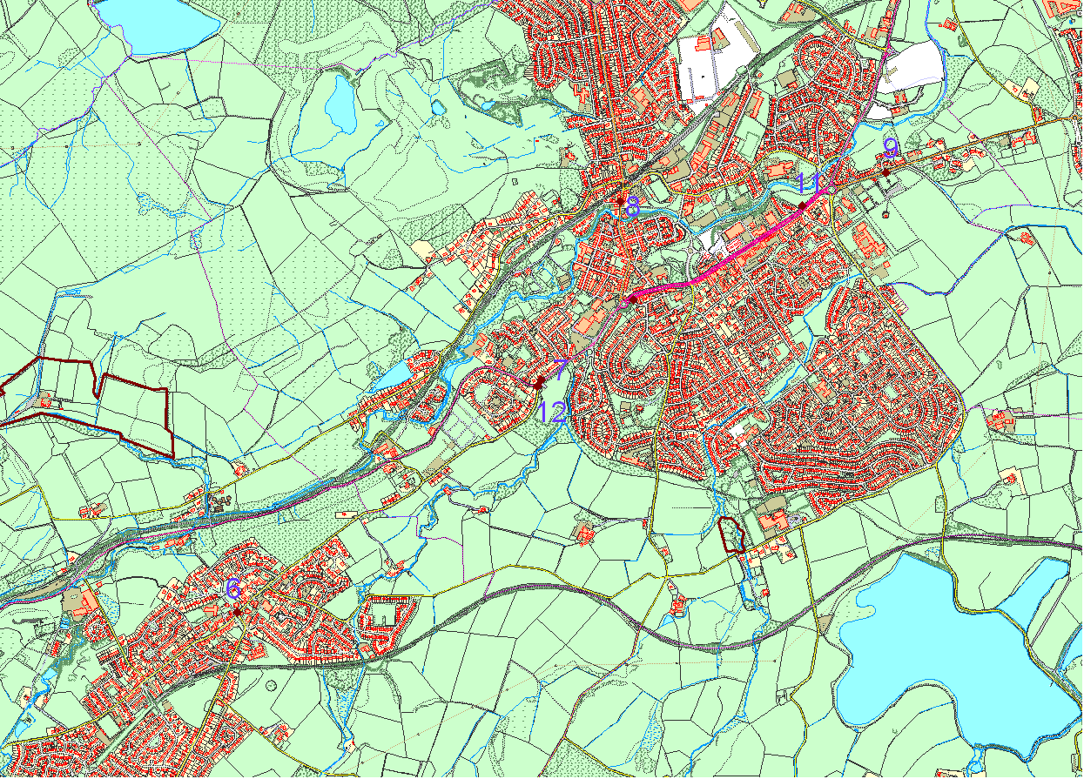
BARRHEAD and NEILSTON
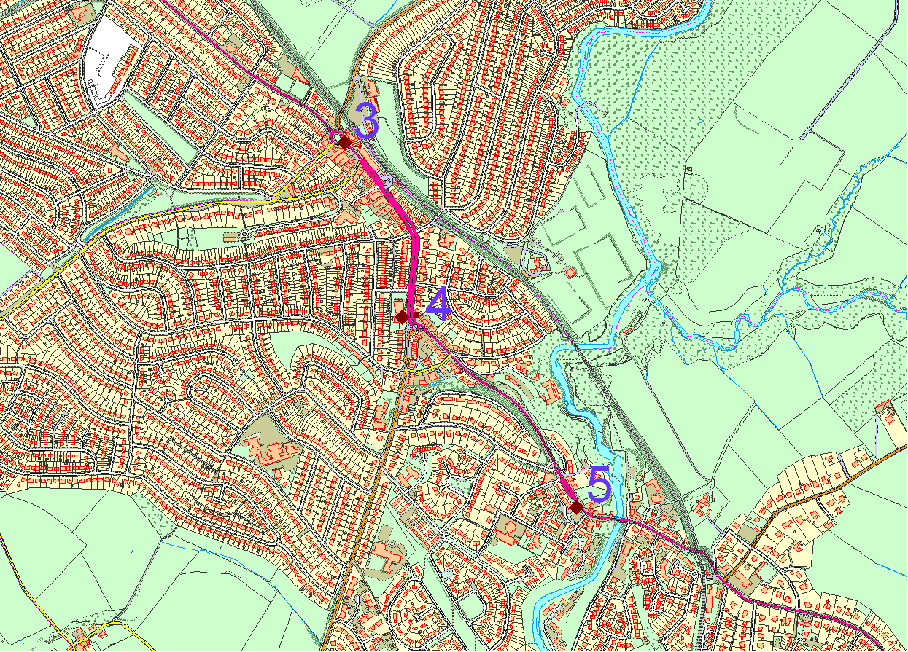
CLARKSTON
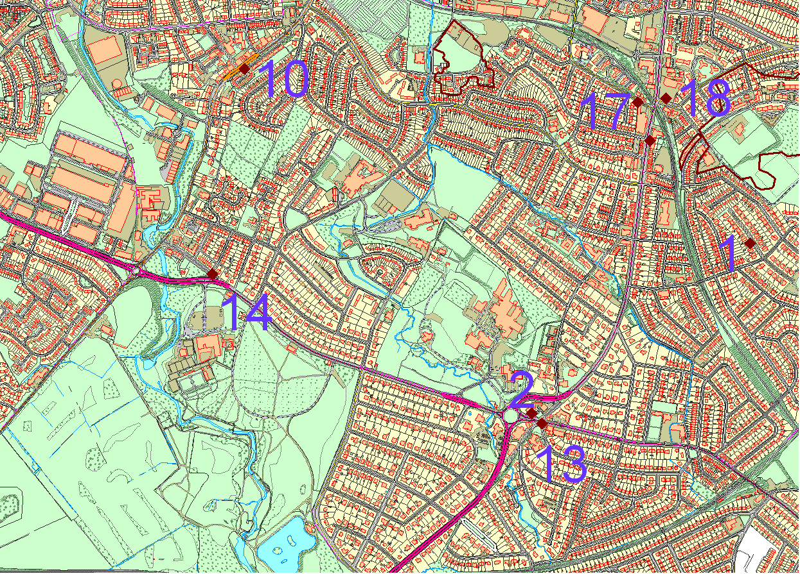
GIFFNOCK and THORNLIEBANK
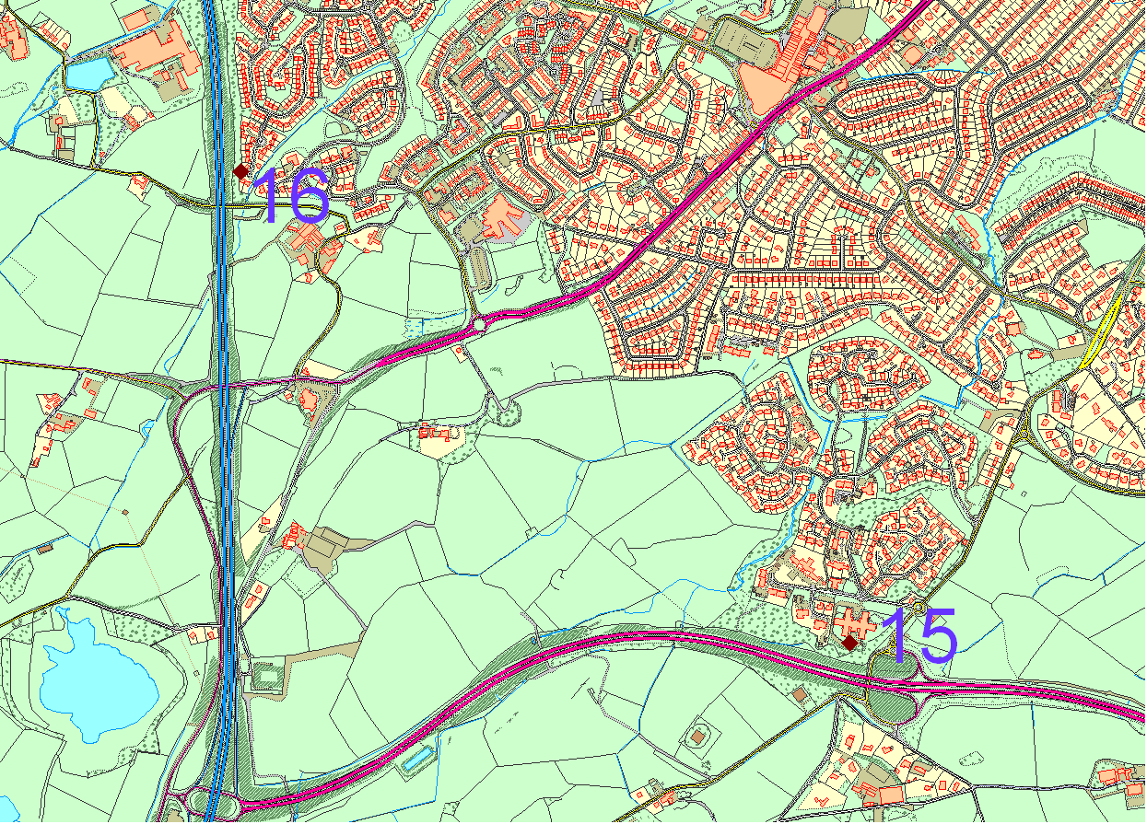
NEWTON MEARNS
APPENDIX B: FULL DIFFUSION TUBE RESULTS 2014
APPENDIX B: FULL DIFFUSION TUBE RESULTS FROM ALL LOCATIONS

SITE NAME | JAN | FEB | MAR | APR | MAY | JUNE | JUL | AUG | SEP | OCT | NOV | DEC | UNCORRECTED AV | BIAS ADJUSTED
Huntly Drive, Giffnock | 27.4 | 12.3 | 2 | 12.8 | 13.6 | 4.5 | 7 | 9.2 | 12.4 | 16.9 | 22.4 | 20.3 | 13.4 | 13.3
Eastwood Mains Road, Giffnock | 89.9 | 31.3 | 19.2 | 30.5 | 22.8 | 7 | 14.5 | 13 | 34.7 | 25.2 | 42.8 | 35.3 | 30.5 | 30.2
Clarkston Toll, Clarkston | 36.2 | 43.8 | 29.5 | 40.9 | 43.9 | 12.3 | 32.4 | 34.3 | 41.9 | 42.5 | 50.2 |  | 37.1 | 36.7
Sheddens R'about, Clarkston | 32.9 | 28.4 | 2 | 25.3 | 29.8 | 14.2 | 20.8 | 18.3 | 25.6 | 29.8 | 39.1 | 37.1 | 25.3 | 25.0
Riverside Terrace, Busby | 36.6 | 23.7 | 22.8 | 22.4 |  | 17.9 |  | 15.3 |  | 36.4 | 34 |  | 26.1 | 25.9
Main Street, Neilston | 32.4 | 29.7 | 25.6 | 28.8 | 20.8 | 8.1 | 14.5 | 14.6 | 16.9 | 19.8 | 28.9 |  | 21.8 | 21.6
Kelburn Street @ Neilston Road Barrhead | 50.2 | 21.2 | 22.7 | 17.8 | 35.8 | 15.3 | 27.3 | 29 | 36.3 | 26.1 | 37 | 36 | 29.6 | 29.3
Cross Arthurlie Street, Barrhead | 53.2 | 30.8 | 34.3 |  | 35.3 | 19.1 | 27.6 | 27.2 |  | 34.6 | 40.5 | 35.3 | 33.8 | 33.5
Darnley Road, Barrhead | 32.5 | 16.9 | 41.4 | 17.2 | 20 | 11.2 | 13 | 15.3 |  | 17.2 | 27.4 | 21.4 | 21.2 | 21.0
Main Street, Thornliebank | 47.3 | 35.8 | 25.9 | 26.6 | 31.2 | 10.3 | 19.7 | 19.6 | 29.3 | 33.5 | 38.3 | 36.2 | 29.5 | 29.2
Main St Barrhead (North) |  | 1.7 | 35.5 |  |  | 10.1 | 14.2 | 15.4 |  | 22.1 |  |  | 16.5 | 16.3
Lochlibo Rd @ W. Arthurlie Cottage | 49.4 | 38.9 | 32.7 | 35.1 | 37.6 | 18.4 | 29.7 | 25.6 | 35.9 | 35.1 |  |  | 33.8 | 33.5
Eastwoodmains Rd @ Mains Avenue | 37.3 | 22 | 33.8 | 21.9 | 28.5 | 16 | 22 | 27.4 | 22.4 | 35 | 28.7 | 27.4 | 26.9 | 26.6
27 Rouken Glen Rd @ gushet | 55.5 | 41.5 | 38.1 | 32.6 | 29.9 | 13.6 | 26.1 | 30.5 | 36.7 | 43.2 | 57.5 | 36 | 36.8 | 36.4
Mearnskirk Nursing home (GSO) | 19.4 | 21.8 | 16 | 11.3 | 11.7 | 5 | 9.4 | 9.5 | 15.4 | 13 | 11 | 13.6 | 13.1 | 13.0
18 Brodick Place (M77) | 28.3 | 11.2 | 23.5 | 20.3 | 18.5 | 14.1 | 21.4 | 18.4 | 24.6 | 25.1 | 11.9 | 27.4 | 20.4 | 20.2
8 Burnfield Road | 36.4 | 8.9 | 40.3 | 14.9 | 27.7 | 7.9 | 12.5 | 10.6 | 20.5 | 28.5 | 14.7 | 24.8 | 20.6 | 20.4
5 Braidholm road | 27.9 | 39.4 | 37.6 | 35.9 | 17.2 | 10.4 | 20.3 | 17.4 | 29.7 | 19.3 | 15.3 | 38 | 25.7 | 25.4

